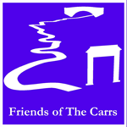
Friends of the carrs Newsletter
Spring 2008

Chairman’s Message
It is with great pleasure that I am introducing the third copy of the Friends of the Carrs Newsletter, and would take this opportunity on behalf of the Committee to wish you all the best for 2008.

As you will appreciate, there has been little opportunity for practical work during the winter, though there has been some bulb planting, which we hope to continue, with the aid of Macclesfield Borough Council over the next few years.

We have also had a Walk around the Carrs, with officials from MBC, to identify a number of safety issues and to discuss future planning.

The real season is now getting under way and I hope that the events which we are organising both meet with your approval, and will be well supported.

Please remember that the Carrs Park is there for your recreation and the Committee is always interested in any suggestions that you may have for maintaining the rural nature of the park, and improving its facilities.

As an example, we were approached about the lack of a path between the Children’s Playground and the main path into the Park. It had been noted that enthusiastic children run into the Car Park to get to the Playgrounds, and this brings children and cars into conflict. As a result of this, a new path is to be built within the Park in an effort to stop children running into the Car Park.

On behalf of the Committee, we look forward to your continuing support throughout 2008.

Ian White
(Chairman of the Friends of The Carrs)

Review of the Park with MBC
Towards the end of 2007, Ian White, Ann Brown and Sandra Savage walked around the park with representatives from MBC to identify areas of the park which required some work.

In this respect, there are a number of tree trunks in the river, as a result of winter floods, which will be removed when the weather improves.

There was a concern about the safety of walkers in the Red Rock area, due to some exposed roots on the grass bank, which could be a hazard. As a result, a fence has since been erected to re-direct walkers away from this uneven ground.

Concern was also expressed about the pathway along the side of the river, leading to the wooden bridge, where river erosion is now affecting the integrity of the path in a number of areas. Under the circumstances, parts of the path will be relaid some distance from the river, which hopefully will make allowance for the erosion to be expected over the next few years.

It was found that a number of trees required some work with respect to unsafe branches, and a decision was also made to plant a number of replacement trees. Native trees, including some oaks along the path from the Parish Hall, will be planted in place of those that were blown down in the gales in spring 2007.

2007 Events
Bulb Plant October 14th 2007
You should notice the Carrs looking more colourful this year. Last autumn Macclesfield Borough Council donated daffodil bulbs to be naturalized in the grass. Some of these were planted around the Chancel Lane entrance to the Carrs by Committee members immediately before the AGM on the 14th October. However the Borough Council were so generous with their donation that a further bulb plant had to be scheduled on the 14th November, this time with the very welcome help of the pupils of Gorsey Bank Primary School.

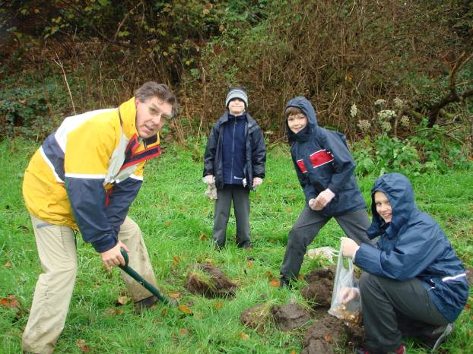
With their youthful energy and the guidance of members of the Committee Ian White, Neil Savage and Councillor Colin Shepherd the remainder of the bulbs were soon planted. A very enjoyable, if muddy, time seems to have been had by all.

We are also very grateful to Neil Savage who acquired some bluebell and wild garlic bulbs from the Mersey Basin Campaign. They have been planted on the slopes in Carrs wood, where it is hoped they will spread and colonise the area over the next few years.

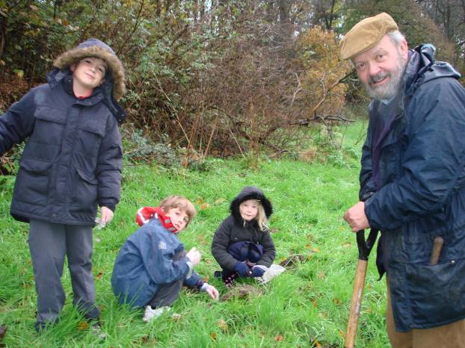
Neil Savage with more willing bulb planters.

Dates for your Diary 2008
It is envisaged that next year there will be a repeat of the very successful Nature Day first held in 2006, a River Clean-up Day and a Balsam Bash.

River Clean up 2nd March 2008
Nature Day 11th May 2008
Balsam Bash 22nd June 2008
AGM and Nature Walk 28th Sept 2008

Watch the web-site or the notice boards for further news. We do hope you will come and join us at one of these events.

Balsam Bash 2008
Another Balsam Bash is scheduled this year on the 22nd June. Balsam, despite having a very pretty flower, is a major pest as it spreads so rapidly and swamps native wild flowers.
This is very true on the Carrs. Previous events made a start on its control, but “Balsam Bashing” is much like painting the Forth Bridge. As soon as you get one area under control another one needs attention. We need as many people to help as possible. Why not come and join us?

Nature Day 2008
A Nature Day will take place on 11th May 2008. This will follow the lead set by the previous very successful day held in 2006 which attracted over 800 visitors eager to learn about the natural history of the Carrs. Interactive events are planned to interest all the family. Teas will be available in the Parish Hall.

Website
Remember that the Friends of The Carrs now have a website where information about the Carrs and plans for events can be found. The address is www.friendsofthecarrs.org.uk.
Work is in progress to allow you to contact members of the Committee via the web-site. At the time of publication of this newsletter there were still a few technical hitches to iron out but keep looking!

Notice Boards
The other method of communication, the planned notice boards should be placed in position soon. They will be positioned on the wall of the Parish Hall, one at the entrance to The Carrs off Hawthorn Lane at the bottom of Broad Walk and one in the Twinnies Bridge car park.

Picnic Tables
One of the pleasures of summer in Wilmslow is taking a picnic to the Carrs. Over the years the state of the picnic tables has deteriorated due to age and also, very sadly, due to vandalism. The litter bins are also a frequent target for vandalism. The Committee are actively involved in evaluating options for replacement for both picnic tables and litter bins.

Annual General Meeting
At the AGM of 4th October 2007 two new members of the Committee were elected, Graham Beech and Tom Brown. The Committee now consists of:
Ian White (Chairman)
Ann Brown (Secretary)
Neil Savage (Treasurer)
Graham Beech
Tom Brown
Richard Doran
Patricia Head
Paul Jabore
Colin Shepherd
Chris Tonge
Jean Webb
Charles Womersley

Contact Names
Chairman: Ian White 01625 532363
(ianwhite@friendsofthecarrs.org.uk)
Secretary:Ann Brown

