
F.O.T.C Newsletter
Autumn 2007

Chairman’s Message

It is with great pleasure that I am introducing the second copy of the FOTC Newsletter.

This has been a year of consolidation, which will hopefully give a sound foundation for the incoming Committee, who will be elected at the AGM on Sunday 30th September.

FOTC are now liaising on a regular basis with the Wilmslow Police Community Action Team (CAT), on misuse of the Park, as well as with MBC regarding the maintenance and improvements to the Carrs.

The spring gales, which brought down a number of trees and blocked a number of the paths, were a good example of what we have achieved . In conjunction with MBC, these trees were quickly cleared to give access and later completely removed. We are now involved with MBC in a tree planting programme to replace the trees lost in the gales.

From the contents of this newsletter, you will appreciate that we have not been idle during the year, and we have planned a number of exciting events during the autumn and throughout 2008.
On behalf of all the members of the FOTC, may I thank my Committee for the hard work and time they have given during the year, with especial thanks to Paul Jabore for creating the FOTC Web Site.

Ian White
(Chairman of the Friends of the Carrs)

Annual General Meeting
The AGM this year will be held on 30th September at 3:30pm in the Parish Hall and will be preceded at 2pm by a bulb planting event. We are grateful to the Mersey Basin Campaign who have donated bluebell bulbs to be planted on the Carrs. Also to Macclesfield Borough Council who have donated daffodil bulbs for naturalising in the grass. Some of these donated bulbs will be planted around the entrance to the Carrs immediately preceding the AGM. Please come and help beautify the Carrs.

Dates for your Diary

It is envisaged that next year there will be a repeat of the very successful Nature Day first held last year, a River Clean up Day and a Balsam Bash.

AGM and Bulb Plant 14th Oct 2007
River Clean up 2nd March 2008
Nature Day 11th May 2008
Balsam Bash 22nd June 2008
AGM and Nature Walk 28th Sept 2008

Watch the web-site or the notice boards for further news. We do hope you will come and join us at one of these events.

2007 Events
Path Clearance May 4th 2007
A dedicated group turned up on a wet day in May to clear this woodland path which leads from along the side of the slope. This had become very overgrown by rhododendron and other bushes. The event was led by Ranger and Participants were supplied with gloves, heavy duty pruners and to the delight of the men bow-saws.
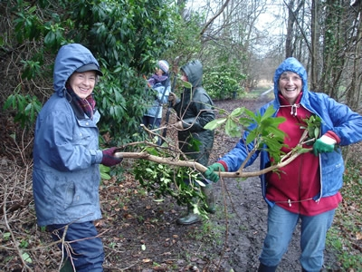Armed with these the group set about the undergrowth with a will, even removing a small sapling at one point.

Balsam Bash 17th June 2007
Rangers Martin James and Christine Robinson led the second assault on the Himalayan balsam which has infested the river bank. They headed a group including representatives from 4th Wilmslow Cubs who gleefully set about pulling up every bit of balsam within reach. It is an exceedingly satisfying work as balsam can be pulled up very easily.
Himalayan balsam is a relative of the Busy Lizzie and was introduced from its native Western Himalayas in 1839 to enhance formal gardens with its attractive green foliage and abundant flowers during the summer. A single plant can set up to 800 seeds so pulling plants up before they seed can form an effective control.
When it dies away in the autumn riverbanks are left bare resulting in erosion. But since it was allowed to escape from a garden habitat the nine feet tall plant has spread rapidly to most parts of the country Its dense growth swamps native wild flowers.
On the Carrs it has spread rapidly. Last year’s event made a start on its control, which was consolidated this year, but a “Balsam Bash” will definitely be needed again next year. Why not come and join us?
River Watch 10th June 2007
Rangers Brian Hallworth and Dan Coates accompanied 15 of us along the length of the Bollin as it flows through The Carrs pointing out the features of the river, the life that increasingly flourishes in it and alongside it. The group learned about the good done by the streamer weed to the river and by nettles to the human body (Brian's authority: his Nanna) and the evil wrought by Japanese knotweed and Himalayan balsam.
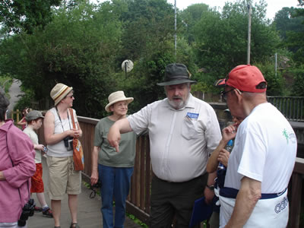
The Rangers confirmed that, yes, the river is getting cleaner, so much so that trout have been glimpsed in some stretches. (Mind you, there was no mention of which stretches - Dan's fisherman's discretion.) The group ended up, definitely better informed, at the new footbridge near Twinnies Bridge having spent a very enjoyable afternoon.
Web-site
The Friends of the Carrs now have a web-site where you can find information about the Carrs, the work of the Friends and also future events. It can be found at www.friendsofthecarrs.org.uk. Many thanks to Paul Jabore who has put in many hours of hard work to get it up and running.

Notice Boards
For those who prefer more traditional methods of communication the Friends have also acquired three notice boards. These will be positioned on the wall of the Parish Hall, one at the entrance to the Carrs off Hawthorn Lane at the bottom of Broad Walk and one in the Twinnies Bridge car park.

Grass-cutting
Next summer you may notice that in certain areas of the Carrs the grass has been left uncut. This will have been done deliberately to encourage the spread of wild flowers such as buttercups, daisies, clover and purple loosestrife into these areas. The Friends are discussing with the Council which areas will benefit most from this treatment. The grass in these areas will be left long into the autumn when there will be a single cut.

Car Park Resurfacing
After pressure from the FOTC the car park has been resurfaced and relined during the summer. The appearance is now much improved.

Tree Planting
Unfortunately storms early in the year resulted in the loss of several large trees on the Carrs. We have to thank MBC Ground Maintenance Team for making the Park safe and clearing the felled trees at a time when substantial damage had been caused to many parks in the area. It is planned that there will be a tree planting program over the winter to replace some of the trees lost in the gales.

Contact Names

Chairman: Ian White 01625 532363
(ianwhite@friendsofthecarrs.org.uk)

Secretary:Ann Brown

