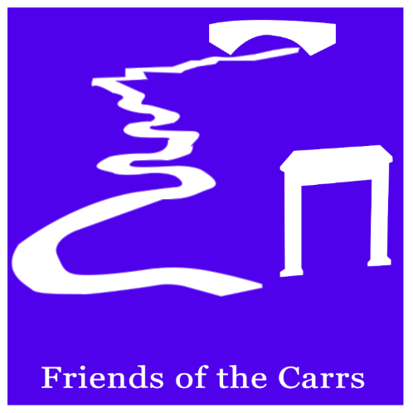
FRIENDS OF THE CARRS
EVENTS CALENDAR 2023
On the second Wednesday of every month there will be an open working party. We meet in Twinnies Car Park at 10.00 a.m., when details of the day’s jobs will be explained. We work from 10.00 to 12.00, but any time you can spare would be appreciated. There will be something to suit everyone, from litter picking to fence repairing and ditch digging. The only equipment you will need will be strong footwear and gloves.
For all other events, meet in the Parish Hall car park.
*Some events require pre-registration with Eventbrite.
Wednesday April 12th Working Party
Sunday May 7th Coronation Celebration
Wednesday May 10th Working Party
Wednesday May 17th *Batty about Bats - Bat walk 8.45p.m.- 10.00 pm. (See Eventbrite web site or notice boards for details)
Wednesday June 7th *Forage Box – forage and balsam bash (9.00am – 1.00pm)
Saturday June 10th *Ecology walk between Wilmslow and Alderley Edge led by Dr. John Handley
Wednesday June 14th NO working Party
Sunday June 18th Balsam bash starting from Parish
Hall 2-4pm
Wednesday July 12th Working Party Balsam bashing

For further information contact ian.baillie@friendsofthecarrs.org.uk

