
FRIENDS OF THE CARRS Newsletter
Autumn 2008

Chairman’s Message
We are approaching the end of another year, and it is hoped that you appreciate the continuing improvements which are occurring around the Park.
We have now started to leave greater areas of Park fallow, in order to improve the environment for wildlife and we are sure that this will increase the number of variety of birds, insects and plants which can be found in this wonderful natural habitat.
The bridges across the river are in the process of being repaired or replaced, and gates and a new path have been installed to prevent a conflict between cars and young children trying to get to the playground. The Parish Hall Car Park has also been refurbished.
New trees have also been planted to replace those blown down in the gales, and a program of bulb planting during the winter has increased the number of wild daffodils within the park.
Our next target is to replace the picnic benches and tables and we are already looking for grants and sponsorship for this major project.
It is unfortunate that we will be losing a number of Committee Members at the AGM this year, due to personal commitments and I am sorry to say that I will also be resigning as Chairman this year, as I am moving out of the area.
The AGM is an important event and I sincerely hope that it will be well attended. The Park is very special to many of us, and we sincerely need to find some ‘new blood’ for the Committee. The tasks are not arduous, and consist of a monthly meeting (except in December and August), lasting for about 1 hour.
I am only too aware of how important this Park is to all of you. This is demonstrated by the number of residents who assist us with the River Clean Up and Balsam Bash. If some of you would be prepared to take a greater interest in the Park, by joining the Committee, it would be of great assistance.
Ian White
(Chairman of the Friends of The Carrs)

Annual General Meeting
The AGM this year will be held on 28th September at 3:30pm in the Parish Hall and will be preceded at 2pm by a nature walk round The Carrs led by one of the Rangers from Macclesfield Borough Council. Please come and join us.

Dates for your Diary
It is envisaged that next year the Friends will organise two Nature Walks, a River Clean-up Day and a Balsam Bash.

AGM and Nature Walk 28th Sept 2008
River Clean up 8th March 2009
Balsam Bash 21st June 2009
AGM and Nature Walk 27th Sept 2009

Watch the web-site or the notice boards for further news. We do hope you will come and join us at one of these events.

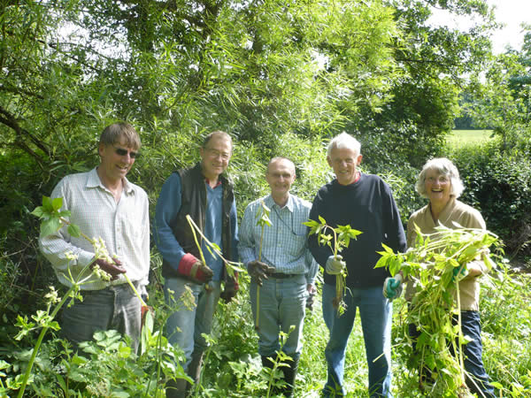
Balsam Bash 2008
2008 Events
River Clean Up March 2nd 2008
A bright Spring day encouraged a good turn out for the annual clear-up of the River Bollin. The group was kitted out with gloves, tongs and bright yellow tabards and, guided by rangers Emma and Martin, set about tidying up The Carrs with gusto. Those equipped with wellies waded into the river, while others braved the brambles to retrieve cans and bottles deposited there. Two skips were filled with rubbish including 5 shopping trolleys, a wheelbarrow and an inflatable boat with a hole in it! Many thanks to everyone who took part.

Balsam Bash 22nd June 2008
A select few turned out on a sunny Sunday morning to attempt to control the spread of the noxious balsam across The Carrs. Previous year’s events have hearteningly almost eradicated it from the upper end of The Carrs, but there are still huge swathes of it near Twinnies Bridge.
The group made up for its lack of numbers with enthusiasm and waded into the balsam with vim and vigour attacking every clump they could reach.
Control of the balsam is not helped by seed spread from large patches over the border of the Styal Country Park. Next year the Committee will co-ordinate with the National Trust to attempt to get these areas under control.

Nature Day 11th May 2008
A superbly sunny day in May brought crowds to The Carrs to enjoy a Nature Day. The day started with the Committee setting off round the Carrs on a litter-picking expedition to ensure it would look its best. They were delighted to discover the early morning dog walkers had got there first and all the litter was already neatly bagged and piled by the rubbish bins. Many thanks to everyone involved.
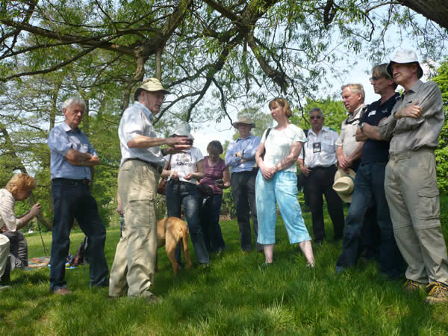
Walks were led by Rangers from Macclesfield County Council throughout the day. Star billing was given to as family of grey wagtails flitting around the river bank. One lucky group was led by Prof John Handley on an extended walk round The Carrs with a short excursion taken into the Country Park to view alder carr and see the type of landscape from which The Carrs developed. He gave a fascinating overview of the ecology of the area and the plants, birds and insects to be found there.
The pond (or rather river) dipping led by Lucinda was a huge success with large groups of children needing no encouragement on such a warm day to paddle in the river. Nets were provided and trays full of interesting creepy crawlies were taken back to the Parish Hall to be viewed in more detail under the microscope provided by Chantelle.

Website
Paul Jabore maintains the website (www.friendsofthecarrs.org.uk) and keeps it up to date. News and photos of all events and a brief history of The Carrs can be found there.
It also now includes a facility for you to put your views or ask questions of the Committee. To contact the Chairman of Friends of The Carrs go to the “About” page and click on “Chairman: Ian White”.

Grass-cutting
This year some areas of The Carrs have been deliberately left uncut. This has been done to encourage the spread of wild flowers such as buttercups, daisies, clover and purple loosestrife into these areas. Already a sprinkling of yellow buttercups can be seen. The Friends are monitoring the success of this approach and will learn from this year’s experience.

New Path and Gate
A new path has been provided along the outer side of the hedge by the car park leading to the playground with a gate to prevent children running into the path of cars in the car park in their eagerness to get to the playground.

Tree Planting
Three new Norway Maples (acer platanoides) have been planted near to the path from the Parish Hall. They should add to the autumn colour on The Carrs by turning a beautiful orange-yellow. Large trees were chosen deliberately to enhance their chances of survival. However the early wet summer has ensured they will not dry out!

Picnic Tables and Benches
Many of the tables and benches on The Carrs are now in a very poor state of repair. The Friends have initiated a survey and have decided that wholesale replacement is needed. This will be a costly exercise, which is beyond the reach of funds available to Macclesfield Borough Council. However one of the reasons for setting up organisations such as FOTC is their ability to apply for funds unavailable to the Council. The Friends are actively pursuing a grant application to fund replacement.

Contact Names
Chairman: Ian White 01625 532363
(ianwhite@friendsofthecarrs.org.uk)

Secretary:Ann Brown

Website: www.friendsofthecarrs.org.uk

