F.O.T.C. NEWSLETTER
Spring 2007

Editorial
This is the first Newsletter produced by the Friends of the Carrs, and it is our intention to produce a Spring and Autumn edition every year from now on.
The Spring Letter will inform you of forthcoming activities planned for the summer, whilst the second will keep you updated of what work has been carried out during the year and our future intentions.
On behalf of the Committee I would like to take this opportunity of thanking you all for your continuing support of the Friends of the Carrs.

Ian White - Chairman

SO! WHAT HAVE WE DONE!!
There were 3 open day events last summer, which were all well supported.

The River Clean-up, in February, was extremely well attended and resulted in 2 skip loads of rubbish being removed from the river. Amongst the items removed were numerous ex-shopping trolleys, 3 bicycles and a selection of traffic cones.

The Nature Day, in May, was attended by over 800 people, both locals and visitors.

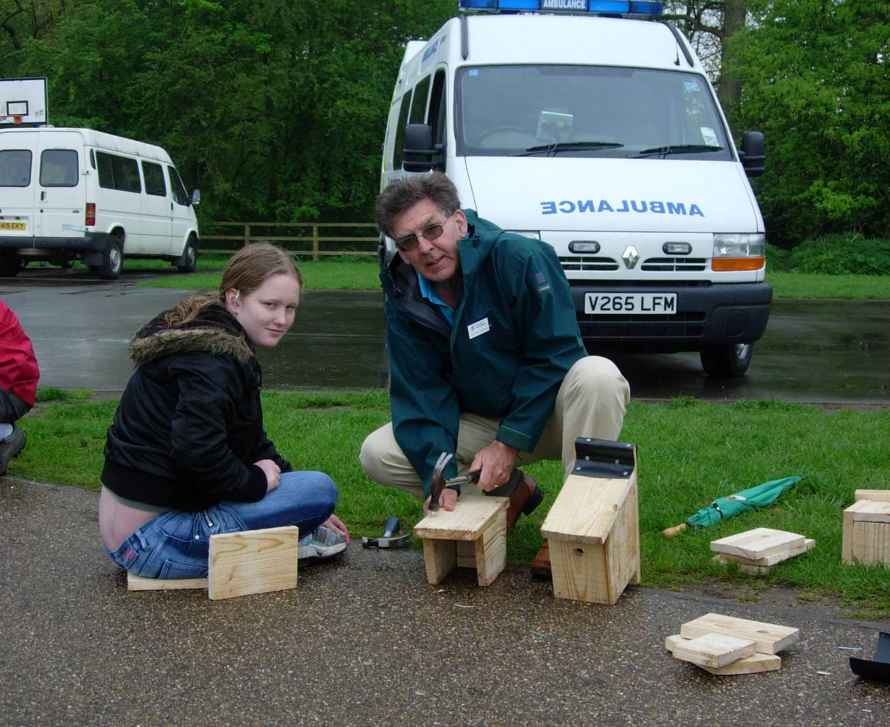
Making Bird Boxes during Nature Day
The “Hands-On” approach to the exhibitions was very successful. We hope to be able to repeat the Nature Day on a bi-annual basis.

The Balsam Bash, in June, was also well attended, and proved to be a good first effort in this annual event, which we sincerely hope will control the Himalayan Balsam and let natural plant species return the river bank.

To all those of you that attended these events, well done!

FORTHCOMING EVENTS
- The Path to St Olaf
Date: Sunday 4th March, 2007
Time: 11 am to 3 pm
Meeting Point: Car Park Parish Hall Wilmslow
Lend a hand by joining us in this practical event to re-establish this woodland path, which has got very overgrown in recent years.

- River Watch
(as part of National Nature Watch Week)
Date: Sunday 10th June, 2007
Time: 10 am to 12.30 pm
Meeting Point: Car Park Parish Hall, Wilmslow
Join Senior Ranger Brian Hallworth for a look at just how rivers affect our countryside, the way we use our rivers, their wildlife and just what things influence them

- The Carrs Balsam Bash
Date: Sunday 17th June, 2007
Time: 10.30 am to 1.00 pm
Meeting Point Car Park Parish Hall, Wilmslow
Lend a hand at the Carrs to remove the fast growing, explosive, and invasive weed, Himalayan Balsam from the banks of the river Bollin.
All tools provided, but bring your wellies

- Annual General Meeting
Date: Sunday 30th September 2007
Time: 1.30 pm to 2.00 pm
Location Parish Hall, Wilmslow
A short meeting to hear the Chairman’s and Treasurer’s report for the year, followed by election of officers for the coming year.

Followed by

- The Carrs Autumn Clean Up
Date: Sunday 30th September 2007
Time: 2.00 pm – 4.00 pm

A chance to carry out a general clear up of litter in the park, before the winter. Tools supplied, but bring your wellies.

The Events up to September can also be found advertised in the Borough of Macclesfield ‘Get Out’ Magazine for 2007.

ANNUAL GENERAL MEETING

The First Annual General Meeting was held on 24th September. There were 13 members present for the meeting, which unfortunately, had been arranged on the same Sunday as the PGA Tournament. This we suspect prevented one or two members from attending.

The Chairman gave a short account of the actions taken by the Interim Committee, who had been steering the Friends of the Carrs up to that first AGM, and a Committee for the year 2006/7 was elected (see list of Committee Members at bottom of page 2)

AUTUMN LITTER CLEAR UP

After the AGM, there was an Autumn Litter Clean up at the Carrs. Can we thank the many members of the general public who were going for a walk that afternoon, who helped with that clear up, especially those that joined the Friends of the Carrs as a result of this event.

The river was too high to allow safe wading, and as a result, we concentrated on general litter. We filled 30 bin bags as a result of those efforts. Thanks to all.

Update on the Parish Hall Car park

The problems with long term parking at the Carrs was the catalyst which brought about The Friends of the Carrs in the first instance, and this subject is still important to us.

There is a proposal from MBC to make the car park ‘Pay and Display’ and there are both advantages and disadvantages to this scheme.

Nothing is going to happen regarding the Car Park in the near future, and MBC are committed to involve The Friends of the Carrs in any decisions regarding Pay and Display.

Little is expected to happen for at least 12 to 18 months.

CAR PARK LINE PAINTING

The white lines on the Car Park should have been maintained over recent years, but were forgotten. This has been brought to MBC attention.

They propose to survey the car park regarding its surface and take remedial action including repainting the white lines. We hope that the work will be carried out in 2007, and FOTC will be keeping this item high on the agenda.

What Litter!

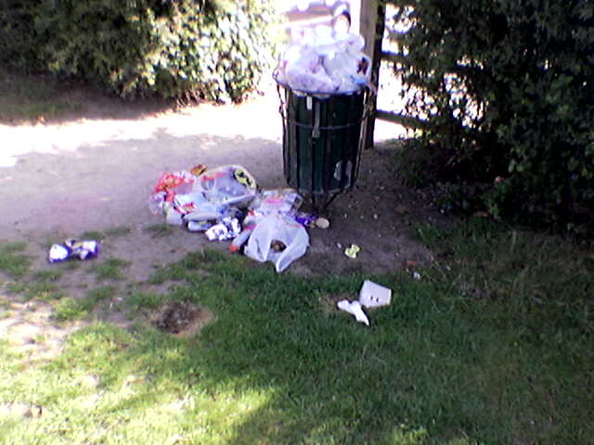

Do you remember when the Park regularly looked like this? It was FOTC who arranged for bigger Litter Bins. We have not been Idle!!

FALLEN TREES

As you are aware, a number of trees suffered damage during the recent gales.

The Friends of the Carrs immediately arranged with the Grounds Maintenance Team for the 2 trees that were blocking the footpath to be cut in order to regain access to the hard walking surface. (It was amazing how the grass turned it into a mini Somme in the space of 3 days as a result of people walking around the trees!)

There are still fallen trees in the park, however, we must all appreciate the substantial damage caused in the gales which is affecting a number of the parks maintained by the MBC Grounds Maintenance Team.

As soon as they have the opportunity, they assure us that will get on site and remove the remaining branches and trunks, but this may take a few weeks.

May we thank the MBC Grounds Maintenance Team for taking such prompt action to clear the footpath into the Park from the Parish Hall Car Park.

BRIDGE OVER THE RIVER DEAN

This Bridge has recently been inspected and is considered to be a hazard. Under the circumstance MBC have scheduled to replace it in March

MATTERS FOR DISCUSSION BY THE COMMITTEE

The following items are appearing regularly on the FOTC Agenda:

- Maintenance of Dog and General Litter Bins
- The Tennis Courts and adjacent building
- River Bank maintenance and bridges
- Footpaths and drainage
- Youth amenities and hands-on involvement of the youths in their maintenance and upkeep.

These are all long term issues, which have been identified by the Committee, but we are sure that you have your own list of priorities or concerns, which you would like to bring to your attention.

Our wish is to act in the best interest of the majority of the members, and if there are any issues you wish to bring to our attention, please do not hesitate to contact us, by phone, letter or e-mail. (addresses at the bottom).

WEB SITE

Many thanks to Paul Jabore, who is working hard on the production of the FOTC web site

Our hope is that this site will be up and running within the next month or two. It is proposed to make this site interactive, to allow members and residents to inform us of matters associated with the Carrs, as well as keeping you informed of forthcoming events and ongoing issues.

The first Web Address is:-
ian.white@friendsofthecarrs.org.uk

MATTERS IN HAND

The Committee are presently looking at the following issues:-

Notice Boards for the Park– These boards are on order and will be installed at suitable points in the park in order that you can be kept informed of useful information regarding both the park and Friends of the Carrs.

Dog Bins and Litter Bins – We are arranging for extra Litter Bins to be available in the Summer, and are
attempting to correctly position the Dog Bin for Hawthorne Lane.

Car Park Maintenance – We are keeping pressure on MBC to get the car park refurbished this year.

NEWSFLASH : Resurfacing is scheduled to take place in March!!

Gale Damage - We are liasing with MBC to clean up the park following the gales in late January.

Youth Involvement - We are in contact with the Youth Leader for the Wilmslow area, and are in discussions with him regarding the best way to involve the youths of Wilmslow in the upkeep, maintenance and preservation of the Carrs.

CONTACT NAMES AND COMMUNICATIONS

Chairman: Ian White
(01625 532363)
(ian.white@friendsofthecarrs.org.uk)
Treasurer: Neil Savage
Secretary: Ann Brown
Committee: Richard Doran
Pat Head
Paul Jabore
Tony Mooney
Colin Shepherd
Chris Tonge
Jean Webb
Charles Womersley

